Please fill in the questionnaire below and return it to us.

Company: Date:
Name:
Dept:
Address: Phone:
Country: Fax:
Activity:
E-mail:

Load to handle :

1. Description :
2. Material:
3. Weight and dimension of the object:
 | Length [mm] | Width [mm] | Thickness mini [mm] | Thickness Maxi [mm] | Weight [kg]
Mini format:
Maxi format:
4. Shape of the load :  round  flat  other:
5. Surface finish of load :  smooth  structured  rough
6. Contamination:  none  dry  wet
❑ oily  dusty  other:
7. Porosity :  airtight  slightly porous  very porous
❑ test necessary (sample requested)
8. Room temperature : °C Ambient temperature : °C
9. Specifications of the load to handle : (for instance drilling etc.; if possible send a sketch)

Handling :

10. Handling characteristics :
❑ horizontal  vertical

❑ swiveling 90°  turning 180

Position of the operator in relation to the load  

11. Working area
Height at which the object is gripped : max: mm min: m
Height at which the object is released: max: mm min: m

12. Workshop height: m
13. Production rate: loading(s) per hour
14. Sketch of handling process:

Energy:

15. Electrical connection: V Hz  3-phase current
❑ Direct current
Pneumatic connection:  available: bar l/min

Cranes or chain hoist: See Appendix 1&2

16. actual installation:  available  requested
A – 1  Crane column : range: m  mural crane : range: m
❑ Rolling crane (zone to be covered): Length m Width m
A - 2  Thickness of concrete slab : mm
❑ chain hoist type: load: kg

Equipments :

17. Paint:  standard  Specific RAL :
18. Options:  Audible warning device in case of Vacuum deficiency (VACUOPAL)
❑ Audible warning device in case of cut of power failure (VACUOPAL)
❑ Integrated battery charger (VACUOPAL)
❑ Gripping/release control with hanging button box
(on standard for Vacuopal 300 kg: sliding valve)
❑ Gripping/release control with fixed console on the handlebar
❑ Integration of ergonomic control on the buttons box of the vacuum lifter
(only if tackle’s voltage = low voltage)
❑ ¼ turn valve insulation of suction cups : Q :

19.Special equipment:

Commercial offer :

20. Order date:
21. Requested delivery date :
22. Appendix :
- Crane or rolling crane sketch
- Sketch of load
- Sketch of handling process

Crane dimensions
Appendix 1

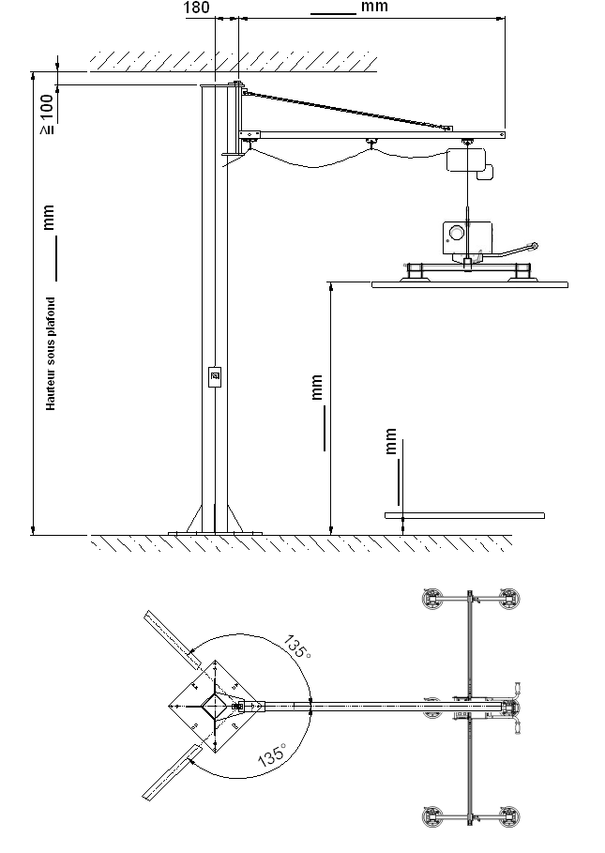
Height under ceiling
Rolling crane dimensions
Appendix 2

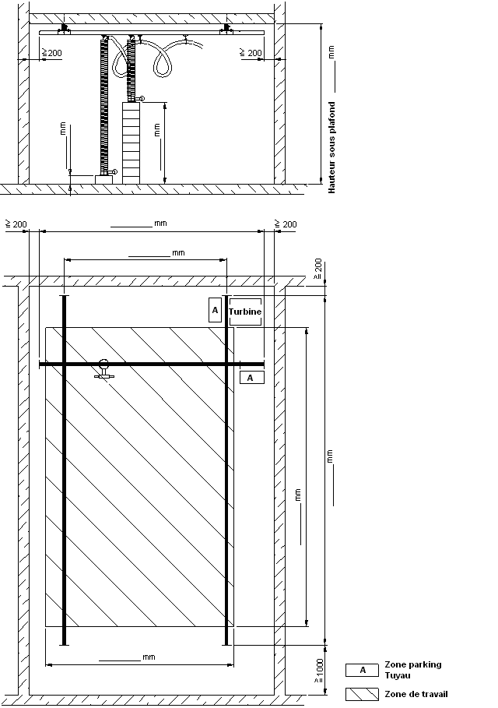
Height under ceiling
Working zone

